Martha B. Puentes, LCAM
Miami Management, Inc.
1145 Sawgrass Corporate Parkway
Sunrise, FL 33323
954-846-7545 (main)
mpuentes@miamimanagement.com

Dade and Broward Counties Properties:
Application Processing through this email: screenings@miamimanagement.com

Customer Service: Phone: (305)259-1401 or (305)259-1407 email: customers@miamimanagement.com

Tenant/Buyer Screening:
https://www.miamimanagement.com/screenings

KINGFISHER RESERVE HOA APPLICATION

The applications for both purchases and sales are completed online using the Miami Management screening portal (https://www.miamimanagement.com/screenings). There is not an expedited fee for approvals. But the portal provides for expedited return of the screening fee, but this does not guarantee the board approval will be provided faster.
Have a great day!
For further assistance please contact the screening departmnet directly at SCREENINGS@MIAMIMANAGEMENT.COM
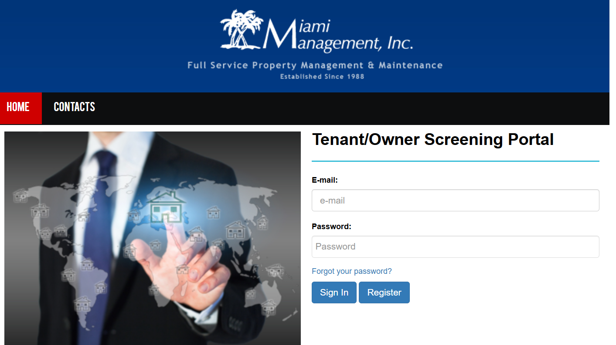

KINGFISHER RESERVE HOA INFORMATION

1. How much is the HOA fee? $315.00
2. What does the HOA fee cover? Insurance, management fee, legal, electricity, storm drain, landscape, irrigation, sprinklers etc.
3. Are there any rental restrictions? (After the home is sold) Can buyers rent the home immediately after purchase? No more than 2 lease months in a 12-month period, no lease term shall be less than six (6) months
4. How long is the HOA approval process? 30 days
5. Is there an application or registration for Buyers/Tenants? Are there any fees associated with it? The applicant must apply at https://www.miamimanagement.com/ click on the screening link and follow the instructions.
6. Where must an HOA application or registration be submitted? Website
7. Do buyers have to submit a deposit with the HOA to purchase? website
8. Are there any special assessments? And/or are there any upcoming that you are aware of? NO
9. What is the best contact information? THE PROPERTY MANAGER
10. How many parking spaces are assigned to this unit? PRIVATE DRIVEWAY
11. Is there a minimum down payment required for the Buyer? N/A MANAGEMENT IS NOT INVOLVED IN THE SALE OF ANY HOMES.
12. Does this HOA accept FHA, VA loans? N/A

